**Advocates push to save World’s languages from dying**

With the declaration [of 2019 as the International Year of Indigenous Languages by UNESCO](https://en.iyil2019.org/), language diversity and language extinction rates have been pushed towards the public eye.

“Language is the vehicle of the community, so when a language goes dormant, it means the community has to some degree collapsed and been unable to sustain itself, and that is indicative of other problems; economic inequality, political oppression, political violence..” said Daniel Bögre Udell, co-founder and Executive Director of [Wikitongues.](https://wikitongues.org/)

 “When a language is revitalized, we're seeing the effects of equity,'' Udell said.

Almost 3 thousand out of the 7 thousand languages spoken worldwide are at risk of extinction. The majority of the languages at risk are spoken by indigenous populations who are often isolated politically and socially in the countries they live in, by geography, history, culture, languages and traditions, says UNESCO.

Udell and Frederico Andrade launched Wikitongues in 2014, a non-profit organization that aggregates videos of individuals speaking languages from all around the world for posterity and access.

Wikitongues is the first public archive of languages in the world. Currently, Wikitongues is finalizing a relationship with the Library of Congress to store their research and resources.

Half of the world's languages could disappear in 80 years and upwards of 95% of languages around the world are underrepresented and under-documented. Having free access to video content of people speaking their language is good for educating the public about the scope and scale of linguistic diversity, Udell said.

Since its foundation in 2014, Wikitongues has archived almost 500 languages, they are looking to archive and help revitalize many more. Unfortunately, metrics to define the health of a language and the success of a revitalization project are poor.

“It’s like a global network of every culture on the planet, and the reason the data is not great, is because when you think about what that looks like...it’s huge,” said Udell.

Some organizations similar to Wikitongues working to track and help revitalize languages are the [Living Tongues Institute for Endangered Languages](https://livingtongues.org/), [Global Voices](https://globalvoices.org/), [Endangered Language Alliance](http://elalliance.org/), [Ethnologue](https://www.ethnologue.com/), [Glottolog](https://glottolog.org/glottolog/language) and [Enduring Voices by the National Geographic.](https://www.nationalgeographic.org/archive/projects/enduring-voices/about/)

**From dormancy to revitalization**

Since 1950, 228 languages have gone extinct and more than 1000 are severely or critically endangered according to the UNESCO Atlas of the World's Languages in Danger.

(use data from here for graphs )

While data pinpoints towards rapid language extinction, some languages have made comebacks.

 “The current situation is drastically different from when it was first measured in the 90s,” said Udell.

Before the ’90s, many governments would crack down on the languages that were not the country’s dominant ones. With the advent of the internet to help spread language awareness and record languages, as well as changes in certain government’s policies, Udell believes today languages are faring better.

In the United States, it was not until 1978 with the passing of the [Indian Child Welfare Act](http://www.tribal-institute.org/lists/icwa.htm) that Native American parents gained the legal right to deny their children’s placement in off-reservation schools.

 “Some Native American parents saw boarding school education for what it was intended to be — the total destruction of Indian culture,” says the American Indian Relief Council.

In 2003, the federal government in Mexico amended the constitution that prohibited language discrimination in public schools. It approved the General Law of Linguistic Rights of the Indigenous Peoples.

Farther up north, the European Council adopted the European Charter for Regional or Minority Languages (1992) and The Framework Convention for the Protection of National Minorities, which came into effect in 1998.

Examples of governments ratifying policies to protect languages can be found around the world. A few cases of languages being revitalized are those of Tunica, Hebrew, Cornish and Catalan.

**Climate Change affects vulnerable populations and minorities more harshly**

In recent months the news has flashed with headlines of wildfires, hurricanes, heat waves, droughts, biodiversity loss and more climate-induced issues.

 “The past three years (2016-2018) have been historic, with the annual average number of billion-dollar disasters being more than double the long-term average,” says a report [“2018's Billion Dollar Disasters in Context” by the National Oceanic and Atmospheric Administration.](https://www.climate.gov/news-features/blogs/beyond-data/2018s-billion-dollar-disasters-context)

(data from this article could serve as a graph for webpage)

The historic number of disasters means trouble not only for the economy of the country but for vulnerable populations and minorities who tend to be most affected by climate change.

Climate change, particularly environmental hazards and sudden-onset disasters, is expected to bring about significant changes in migration patterns throughout the developing world, says Assessing the Impact of Climate Change on [Migration and Conflict by Social Dimensions of Climate Change.](https://siteresources.worldbank.org/EXTSOCIALDEVELOPMENT/Resources/SDCCWorkingPaper_MigrationandConflict.pdf)

[The Living Tongues Institute for Endangered Languages produces a Language Hotspots map,](https://livingtongues.org/language-hotspots/) where it pinpoints locations around the world that need action and should be the highest priority in planning future research projects and channeling funding streams.

The hotspots are located in the Northwest Pacific Plateau, Central and South America, Central Siberia, Eastern Siberia and Northern Australia.

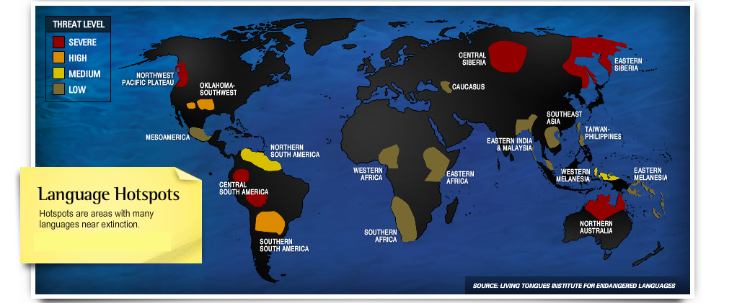

“(climate change) provokes refugee migrations...these communities who, for however long had a measure of cultural sovereignty no longer have it because they’re forced to relocate and settle in places where they have to assimilate,” said Udell.

 Rapid urbanization or economic reasons also rank high for communities displacement, Udell added.

While tracking current climate effects on languages is difficult, Udell said he was confident that 20 years from now, research would show communities who had been negatively impacted by climate change.

This impact could be traced back to the breakdown of The Paris Agreement and Brazilian President, Jair Bolsonaro’s current policies regarding the Amazon forest, amongst other reasons, Udell said.